Old Money System

Version 1

Author: Daniel Carvalho Marques

This package focuses on the old money system of £sd (<https://en.wikipedia.org/wiki/£sd>). £sd being pounds, shillings & pence.

SampleScene contains:

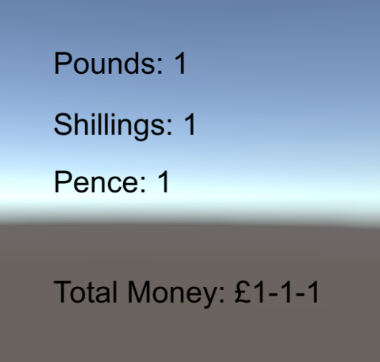

Q raises the value of pounds by 1, E raises the value of shillings by 1, E raises the value of pence by 1.

SampleScene2 contains:

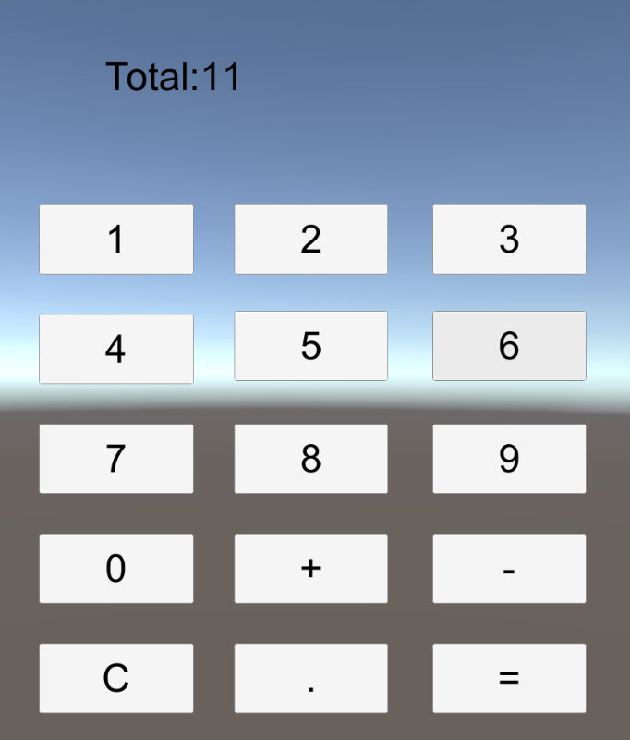

A somewhat functioning calculator; the number buttons when pressed add that number to the total and the C button clears the total.

SampleScene3 contains:

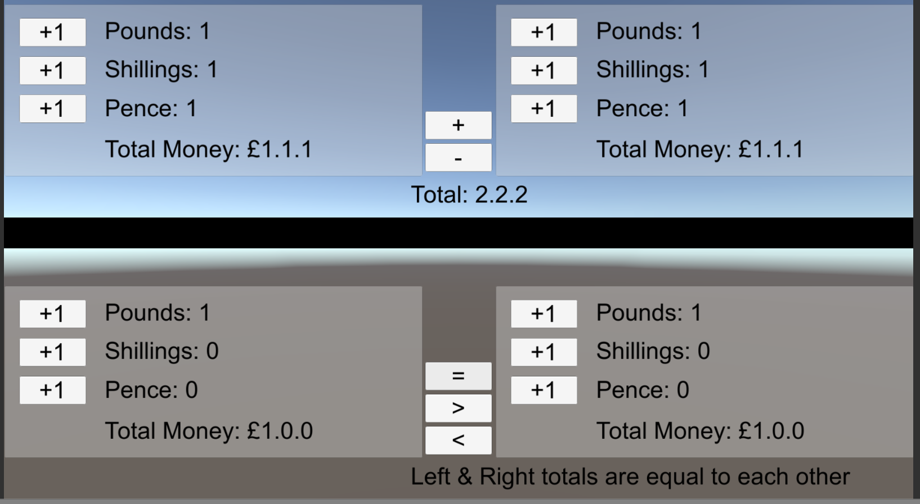

Firstly, the black bar divides the 2 Main functions of this ‘calculator’, the top half & the bottom half.

The +1 buttons next to the pounds, shillings & pence raises the corresponding pounds, shillings & pence.

For the top half of the screen the + button adds the right total money to the left total money. Whereas the – button takes away the right total money from the left total money.

For the bottom half of the screen the = button checks if the left total money is the same as the right total money. The > button checks if the left total money is greater than the right total money. The < button checks if the left total money is less than the right total money.